**Streaming using Smartphone as relay**

**(via Bluetooth)**

**INTRODUCTION**

This project involves streaming/sending a music file from one device (sender) to the other device (receiver) through the third device (Relay). These devices make use of Bluetooth to transfer the file. Transfer is possible only if the communicating devices are within range, else the main concept behind the problem statement arises.

**PROBLEM STATEMENT**

Problem arises when the receiver (tablet or smart-phone) is not in the range of the sender. In this case, the sender makes use of the relay. The audio file is then streamed to the sender through the relay.

***Relay:***

A relay is a connecter between the two communicating devices which facilitates the process of streaming the file from the sender to the receiver, when these two are not in range of communication. It acts as a middle men by transferring the file from source to destination.

**ABSTRACT**

An android application “Bluetooth share” allows three devices A, B and C to stream music file from the sender(A) to the receiver(C) through the relay(B). The sender first establishes a connection with the relay which acts as a receiver. The music file sent from the sender to the relay is stored in a temporary buffer. The relay then establishes a connection with the receiver and streams the data stored in the temporary buffer to the receiver. In this way the relay plays an intermediate role is streaming the music file from the receiver to the sender. Once the sufficient data is streamed from the relay to the receiver, the music file is played which was stored in the sender.

**PROPOSED SYSTEM**

To develop an android application which will have the functionality of sender, receiver and relay. Simple user interface has been implemented to guide the user to use the functionalities of the sender, receiver and the relay. The relay acts as a bridge between the sender and the receiver. Both the sender and the receiver will be connected to the relay. Once all the devices are interconnected, the list of songs present in the sender will appear in the receiver too. Once the user selects the song of his choice from the list, it is fetched from sender device and streamed to the receiver through the relay. When the user hits the player button, the streamed song starts playing.

**ARCHITECTURE**

We have implemented a three-tier architecture which have a UI and that UI is connected to the backend logic which we used to make the application functional. We used a database which was connected to the backend logic.

In this application when we open our application we come across a screen where we have to select whether we want our device to be sender, relay or receiver. If we have entered in the database whether the given device is sender, relay or receiver then the device automatically adapts that role and the respective screen opens.

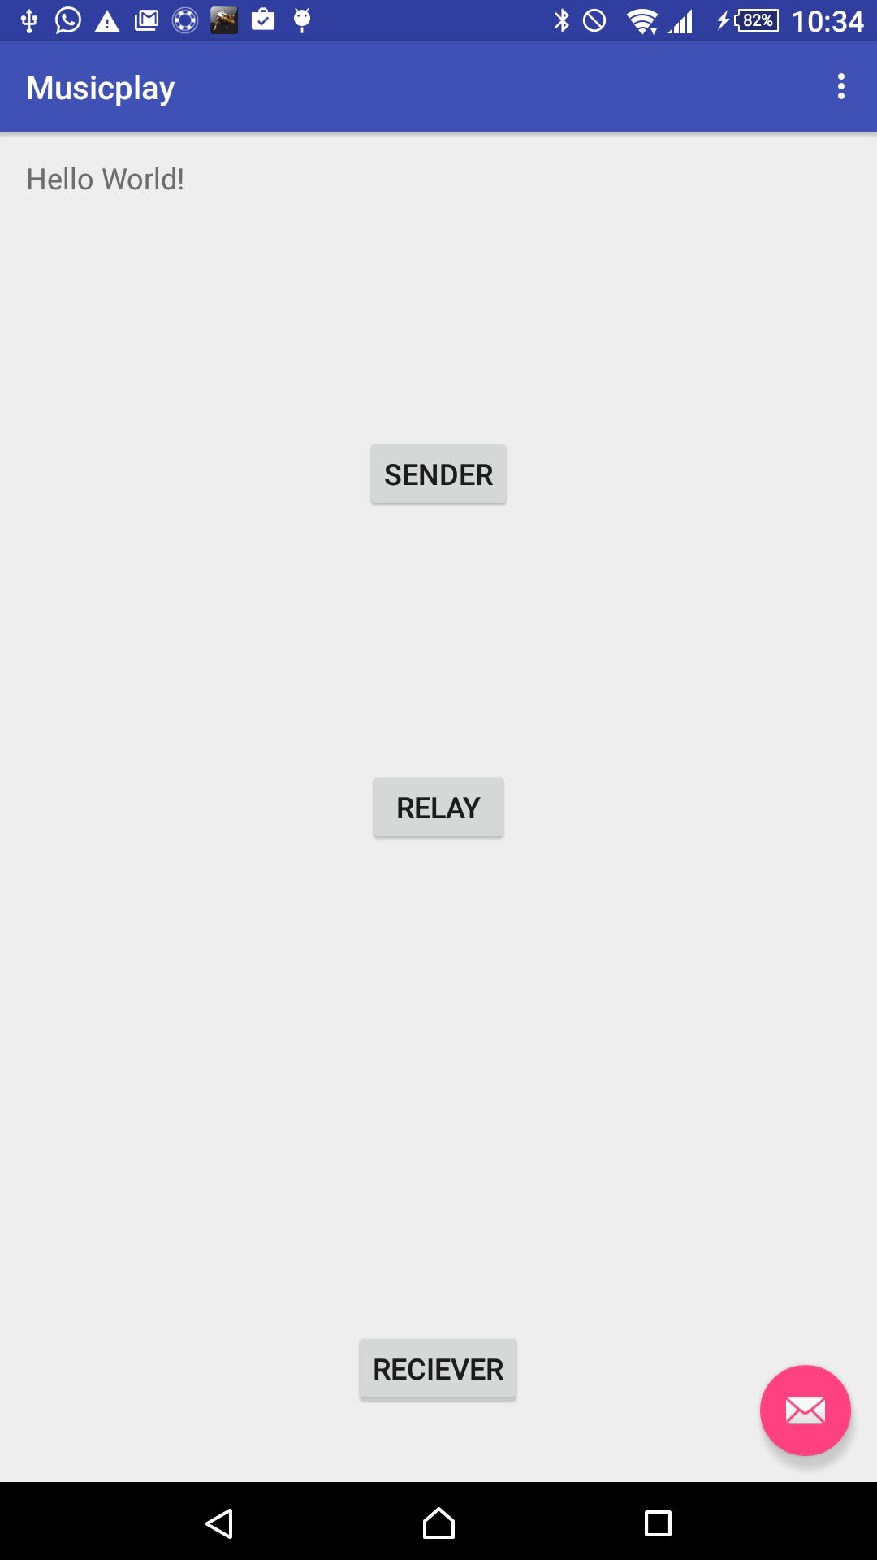

We have created a class name “Sender.java”. This class has all the functionalities that are required by the sender class to connect to the relay and send the data from sender to relay. We can see a list view which is populated with the paired Bluetooth device present in the system. If the Bluetooth device is not paired with each other then we have to pair them manually. Once they are paired they will appear in the list view. When you click on the list view one a connection socket is created and a socket request is send to the relay device using the Bluetooth MAC address.

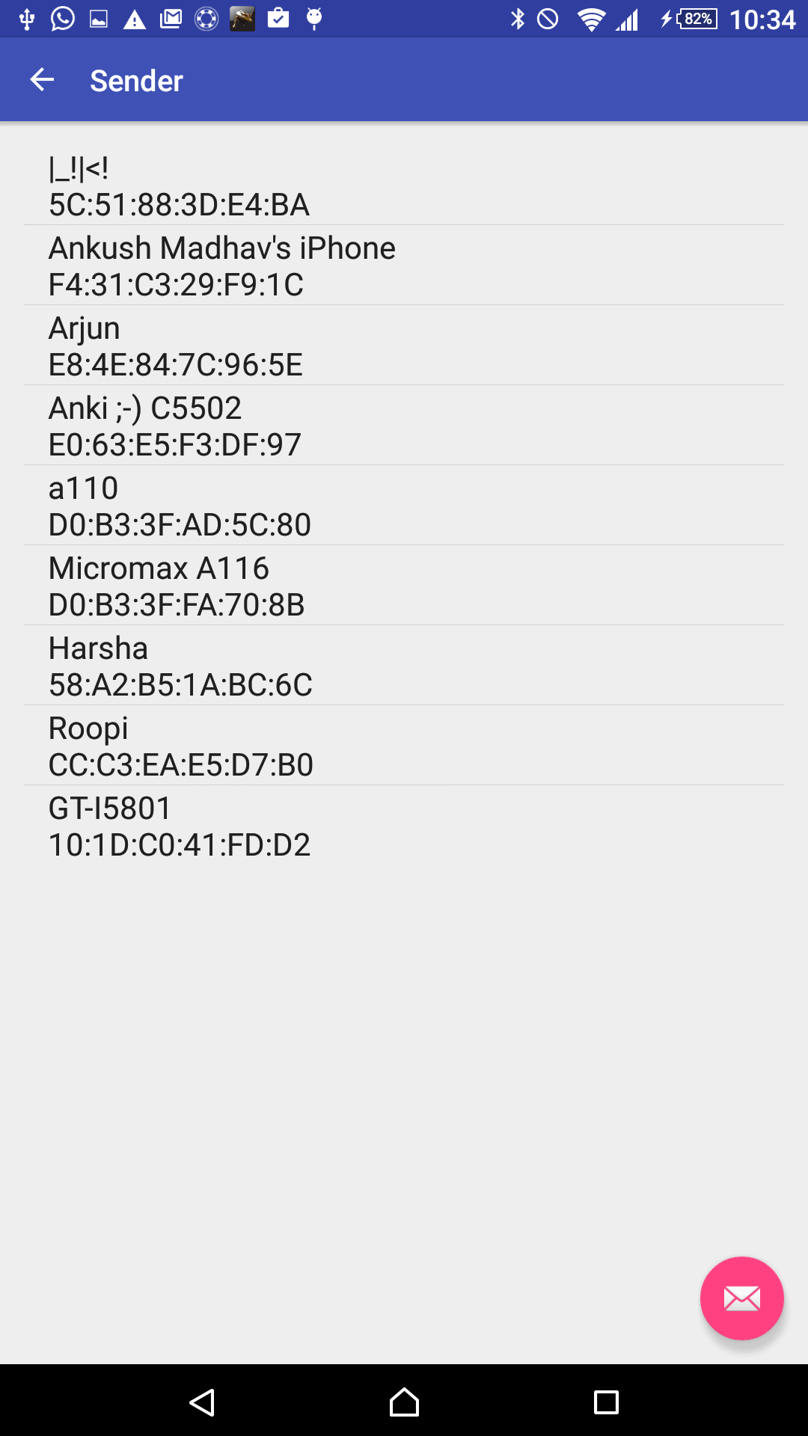

Once the sender requests a connection the relay accepts the connection request opening Bluetooth socket connection request from the sender device. Now the whole functionality of the relay device is written in two classes ‘Relay.java’ and ‘ThreadToBeConnected.java’. In ‘Relay.java’ we are accepting the connection and opens up a connection with the sender device. Once it is establish it also accepts a list of names of files of songs from the sender device. The connection is established as it was established between sender and relay. Now when the receiver establishes the connection with the relay it will accept the list of files and send the request of back to the receiver.

Now when the receiver accepts the connection from the relay, it will get a list view from the sender it will populate its list view. Now, when you click on the name of the song it will send a request to relay. When it starts accepting the data from the relay, it will generate a temporary file. This temporary file will be then used to stream the data.

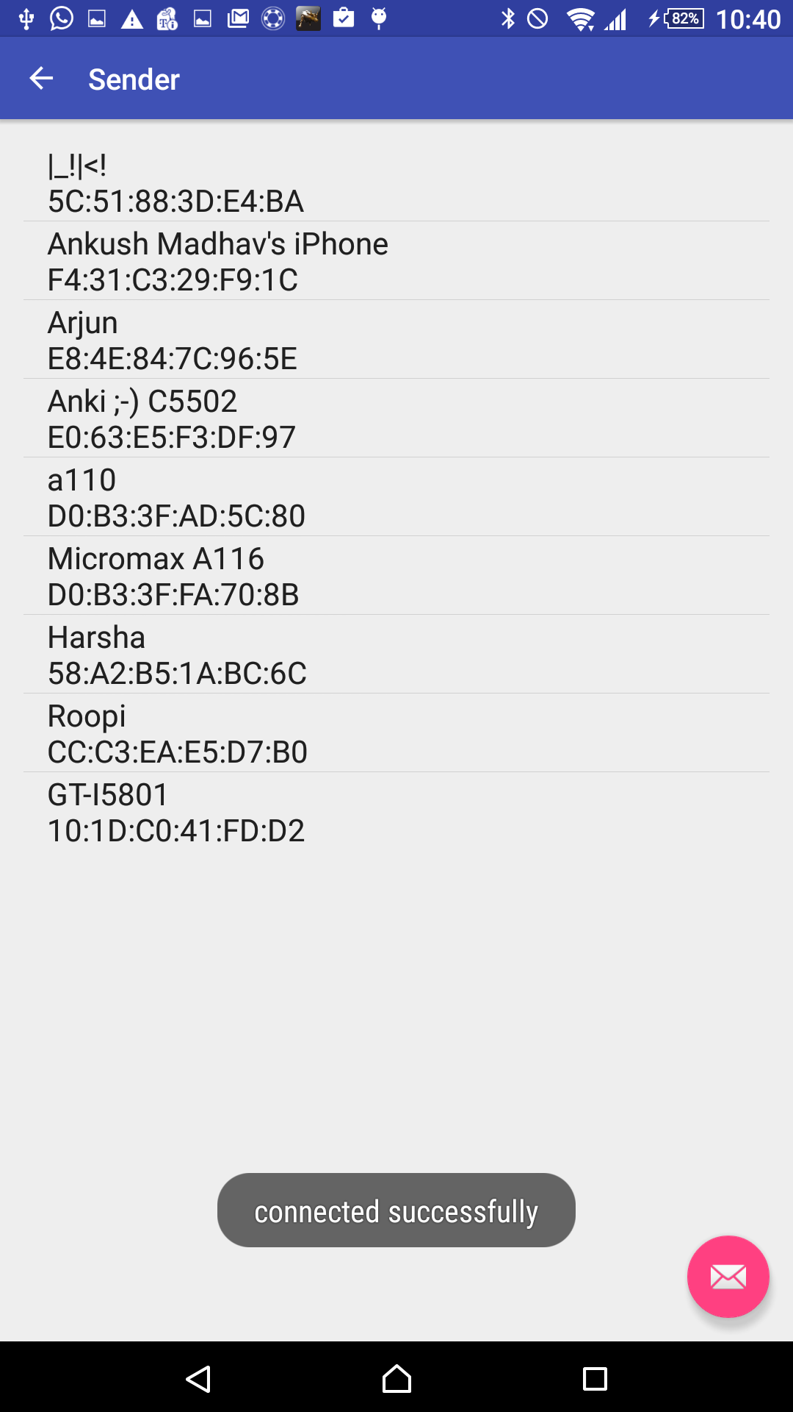

DRAWBACKS

There are a few drawbacks about this application. They can be worked up on in the future making the application more dynamic. They are listed as follows:

1. Socket connection for Bluetooth versions were not supported in different android versions. 2. The file name and the owner name have to be mentioned in the code manually.

***References:***

* <http://stackoverflow.com/questions/7273084/how-to-programatically-connect-2-android-devices-with-bluetooth>
* <http://developer.android.com/guide/topics/connectivity/bluetooth.html>
* <http://stackoverflow.com/questions/18109479/howt-to-connect-two-devices-via-bluetooth-sending-the-pairng-code-by-parameter>
* http://www.glowingpigs.com/index.php/extras